
Sanjel Energy Services

Program Request Management Module

Functional Requirements Document (FRD)

Contents
1. Introduction 3
2. High-Level Workflow 3
3. Functional Requirements 3
4. Non-Functional Requirements 13
5. Reporting & Analytics 13
6. Future Enhancements 14

1. Introduction
1.1 Purpose
The purpose of this document is to define the functional requirements for the Program Request Management Module. This system will automate and standardize the intake, assignment, prioritization, review, approval, and tracking of job design program requests.
1.2 Objectives
- Streamline program request handling.
- Eliminate manual assignment of Engineers.
- Ensure approvals align with complexity matrix and service lines.
- Prioritize requests based on Due date
- Notify stakeholders at key stages.
- Maintain auditability and reporting for all requests.
1.3 Scope
The system will support requests submitted by Sales, Clients, or Dispatch. It will integrate with FreshService or a new custom application, manage approvals per complexity matrix, and generate reports on request progress, classification, and outcomes.

2. User Roles
2.1 Sales / Dispatch
- Responsibilities:
  - Submit program requests via email forwarding or portal form.
  - Attach supporting documents (stick diagrams, licenses, client data).
  - Receive acknowledgement and completion notifications.
  - Access program status visualization to track request progress.
  - Review program once approved for pricing or client submission.
- Permissions:
  - Create requests.
  - View status of their submitted requests.
  - Download final program documents.
  - Search requests by client, date, or Program ID (limited to their submissions).

2.2 Engineer
- Responsibilities:
  - Receive auto-assigned program requests.
  - Draft, revise, and prepare job design programs.
  - Trigger auto reviewer or Approval Assignment/Notification to mapped Agent
  - Address review/Approval approval or rejection comments and resubmit programs.
  - Upload final versions of program documents.
- Permissions:
  - View and edit assigned requests.
  - Upload and manage draft documents.
  - View Review/approval history for their programs.
  - Search requests within their assigned clients.

3.3 Manager – Engineering
- Responsibilities:
  - Assign requests without a mapped Engineer.
  - Oversee Engineer workload distribution.
  - Review and approve job types with yellow and red matrix scores.
  - Ensure timely resolution of urgent or escalated requests.
- Permissions:
  - View all program requests across service lines.
  - Override auto-assignment rules if needed.
  - Approve/reject requests according to matrix rules.
  - Generate workload and performance reports.

4.4 Director / VP (Sales & Engineering)
- Responsibilities:
  - Provide top-level approval for Black matrix programs.
  - Oversee compliance with approval rules.
  - Review metrics for program performance and approval cycles.
- Permissions:
  - Approve/reject high-complexity (Black) requests.
  - Access full system reports and analytics.
  - View historical program archives across service lines.

4.5 Approvers (Peer / Lead / Manager / Director) Engineers
- Responsibilities:
  - Review assigned programs based on matrix color.
  - Approve or reject with comments.
  - Ensure compliance with standards before release.
- Permissions:
  - Approve/reject requests with role-based visibility.
  - Add review notes.
  - View program lifecycle and history.

4.6 Operations / Field Team
- Responsibilities:
  - Access approved programs for execution.
  - Download final PumpingPDFPrograms for field operations.
  - Provide feedback into system for continuous improvement.
- Permissions:
  - Read-only access to approved requests.
  - Search historical programs by client, location, or service line.

4.7 System (Fresh Service / Custom App)
- Responsibilities:
  - Auto-assign requests based on mapping.
  - Generate Program IDs.
  - Send notifications at each workflow stage.
  - Track timestamps for all lifecycle events.
  - Log all actions for audit purposes.
- Permissions:
  - Full automation rights.
  - Access to all system data for reporting and analytics.

3. High-Level Workflow
1. Sales/Dispatch submits a program request.
2. System logs the request and generates a Program ID.
3. Request is auto assigned to the correct Engineer based on company mapping.
4. Request is prioritized based on due date and matrix color.
5. Request undergoes reviews/approvals according to matrix rules.
6. Notifications sent to Sales, Engineers, Approvers.
7. Approved program is returned to Sales or directly to Client.
8. Program is archived and logged in database.

4. Functional Requirements
4.1 Request Intake/Meta Data Fields
Description: When Sales, Dispatch or Engineer submits a new Program Request via email forwarding or portal form, the system logs the request and generates a unique Program ID.
System shall support request submission via:
- Email forwarding (email for fresh service is help_6@sanjel.freshservice.com)
- Web portal form.
Standard Fields (Current Fresh service):
- Subject
- Requester
- State
- Status
- Priority
- Assigned To
- Status Details
- Department
- Source
- Created Date
- Last Modified Date
- Due Date
- Closed Date
- Approval Status
- Workspace
- Association Type
- Requester Location
- Requester VIP
- Resolved Date
- Impact
- Urgency
- Category
- Sub-Category
- Item
Required Fields (Customizable):
- Request Date
- Subject
- Due date
- Client
- Requestor
- Requestee
- Acknowledgement
- Completion Date
- Rig Name and #
- Well Location/pad Name /Area Name
- Request Type (e.g., program generation, RFP, revision, simulation, RFI, RFQ,
etc.)
- Program ID
- Program Type (Surface, Intermediate, or Production may include a single type or a combination of two or all three.
- CMS
- Service line (Primary, Remedial, Stimulation, Infrastructure)
- Complexity Matrix (CM) Color
- Time to complete (Days0
- Late (Yes/No)
Required Fields | Description
Request Date | Covered with current field #10.
Due Date | Covered with current field #12.
Client | Would need to create a special field for this.
Requestor | Covered with current field #2.
Requestee | Covered with current field #6.
Acknowledgement | Could likely be covered in current field #4 but would need to understand if this should be a stand alone field or can be incorporated into another field.
Completion Date | Covered with current field #13.
Rig Name and # | Would need to create a special field for this.
Well Location/Pad Name/Area Name | Would need to create a special field for this.
Program Type | Would need to create a special field for this. Would need all the different Job Types.
Program ID # | Would need to create a special field for this.
CMS | Would need to create a special field for this.
Late | Might be able to utilize current field #12 to determine this depending on the options available. If the Fresh Service can recognize the due date to the actual date then make the #12 field red or something then may not need this field.
Service Line | Would need to create a special field for this (Primary, Remedial, Stimulation, Infrastructure).
Request Type | Would need to create a special field for this (Program, Bid Program, RFI, Simulation, Program Revision, RFP, etc.).
Subject | Covered under current field #1, just may need to be able to include more information as fields are filled out.

Field Display Customization:
- The system should provide a clickable box (field selector) enabling stakeholders to choose which fields they want displayed in their task bar.
- Each stakeholder’s view shall be customizable without affecting others’ views.

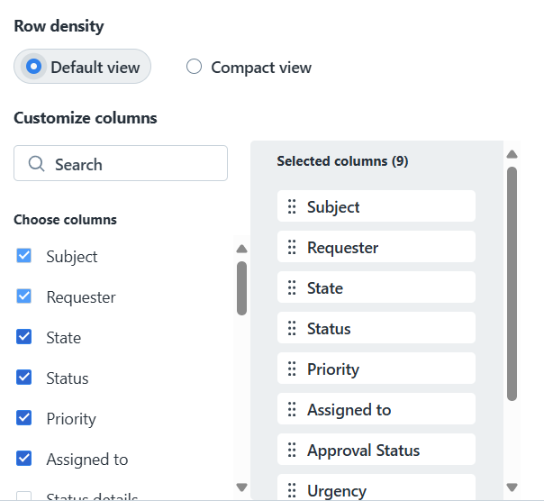

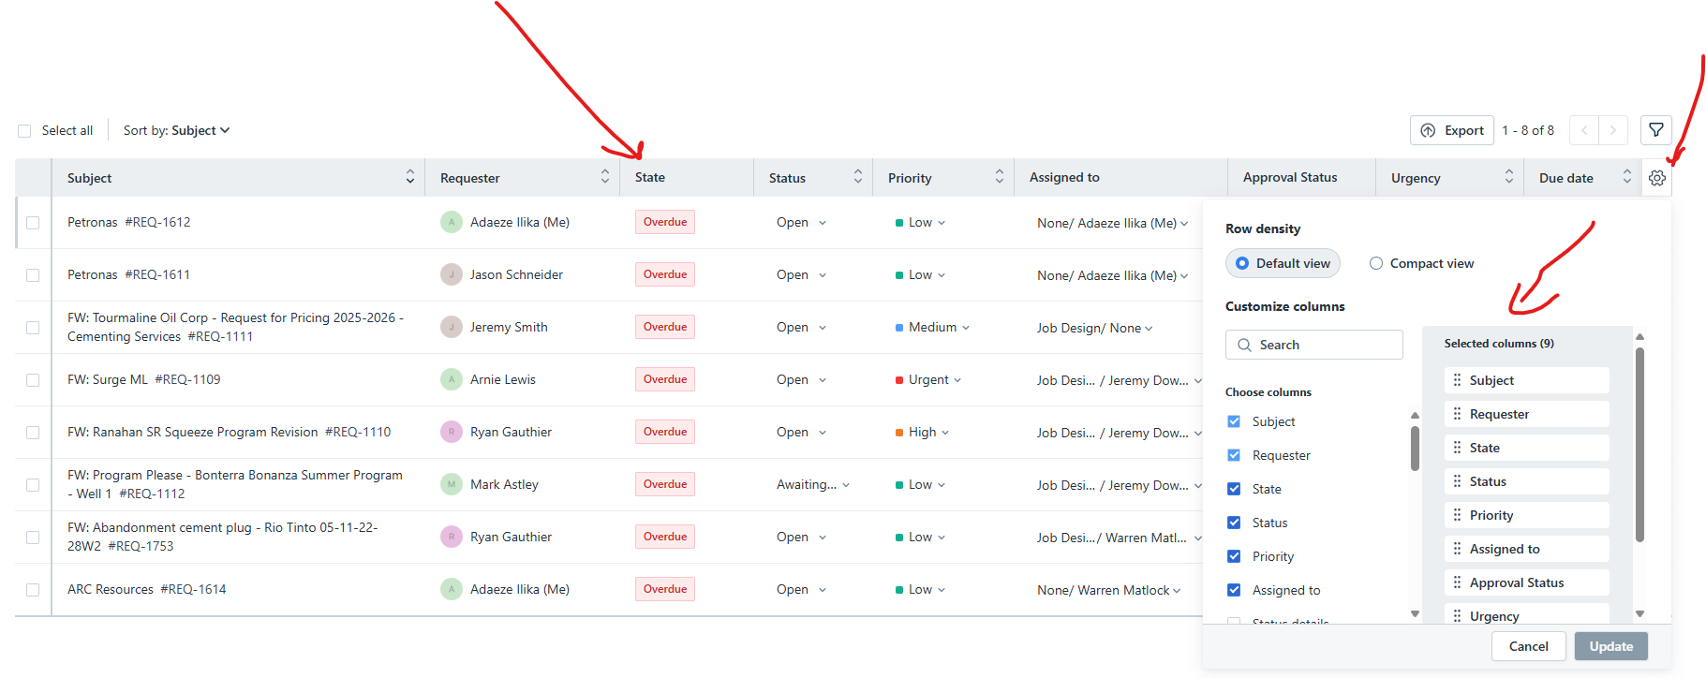
4.2 Request Summary in Subject Line
Description: When Sales or an Engineer forwards an email to Fresh Service to create a Program Request, the system must automatically generate a dynamic subject line (Summary) instead of a static request number. The Summary will update once additional details are provided, making requests easier to distinguish at a glance.
Pre-condition:
- A Program Request is submitted via email forwarding or intake form.
- The following fields are captured in the request: Client Name, Request Type, Service Line, Unique Identifier, and Bid Indicator (if applicable).
Post-condition:
- The subject line is updated to include key attributes in a concise summary format, such as:
  - Client name
  - Request type
  - Service line
  - Unique identifier (e.g., LSD or pad)
  - Bid indicator (if applicable)
- The static “Subject” field is replaced by the dynamic Summary field.
- The Summary serves as a brief overview of the request context, ensuring requests are easily distinguishable from one another in the system, notifications, and reporting.
- Engineers, Managers, and Sales can quickly identify the purpose of the request without opening the full ticket.
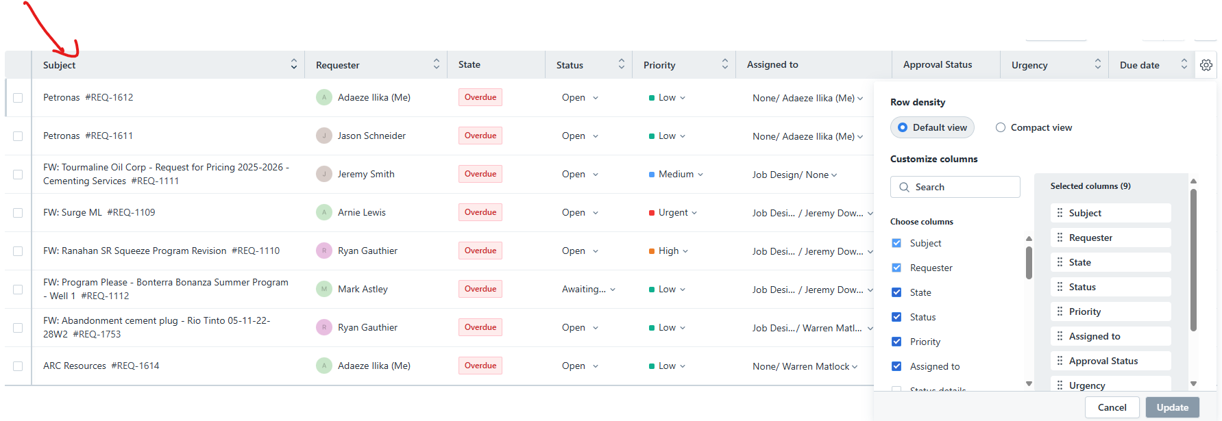
4.3 Ticket View Configuration
Description: When an Engineer opens a Program Request ticket, The system to display ticket information in a structured layout to provide Engineers with all relevant details and supporting content for efficient resolution.
Current State (Fresh service default):
- Details
- Related Tickets
- Tasks
- Assets
- Associations
- Approvals
- Activity
- Resolution
Required State (Engineer-preferred):
- Details
- Related Tickets
- Tasks
- Reviews
- Approvals
- Activity
- Resolution (Add a Note: The resolution note outlines the actions taken to resolve an issue, providing a clear record of the steps and solutions applied)
- Full email content (including original message)
- All attachments associated with the ticket (emails + attachments).

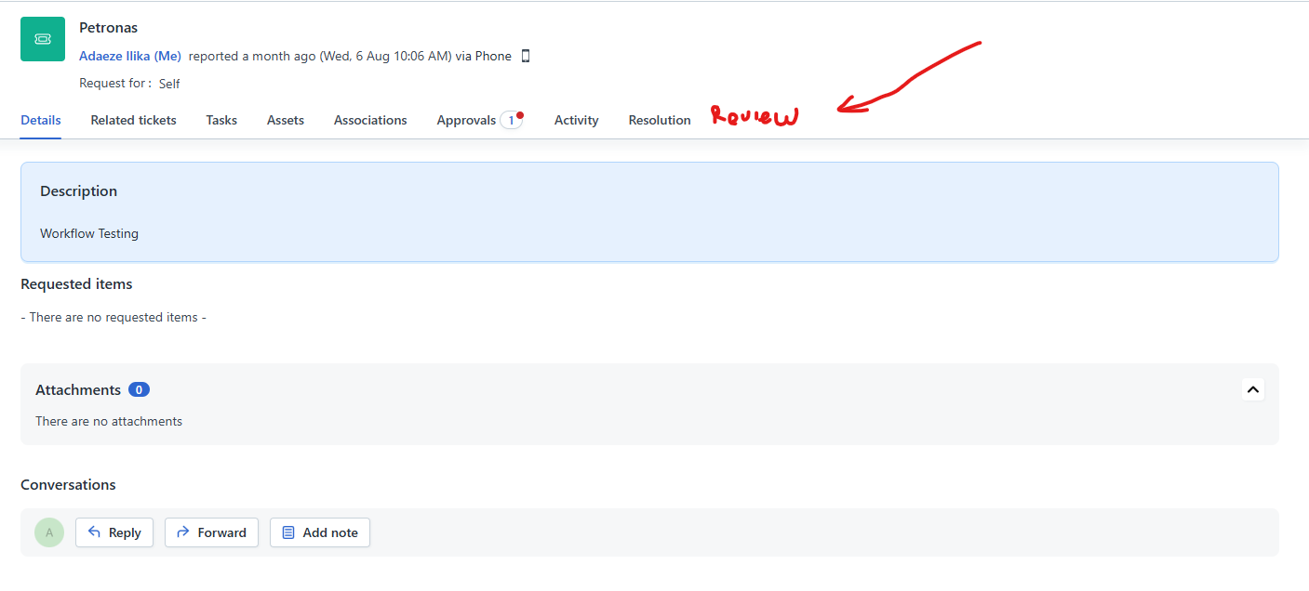
4.4 Auto-Assignment
Description: Based on the company name on the forwarded email by Sales/Engineer or when a Program Request is logged, the system automatically assigns it to the correct Engineer based on the Company name → Engineer mapping.
The system shall maintain a Company–Engineer mapping table to automate assignment of requests to Engineers. The table shall define which Engineer is responsible for each company (e.g., Enmax → Warren).
Assignment Rules:
- If the company exists in the mapping table → assign to the mapped Engineer.
- If no mapping exists → assign to the Manager–Engineering.
- If the request is marked urgent or received after business hours → route to the on-call Engineer.
Notifications:
- The assigned Engineer shall receive an email notification containing a clickable link redirecting them to the App.
- The system shall also generate an in-app notification to alert the Engineer of the new assignment.
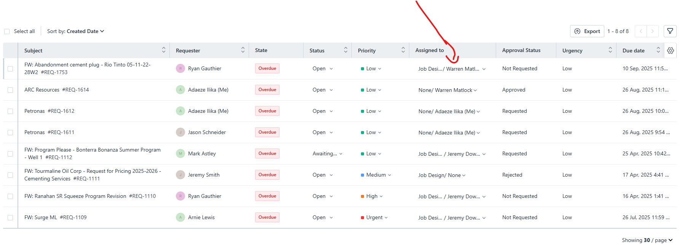

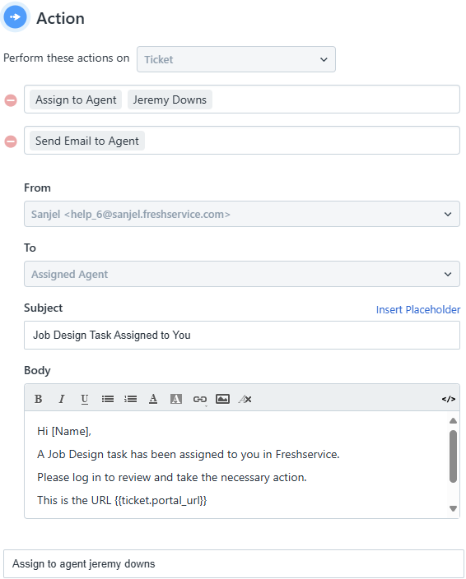

4.5 Prioritization
Description: When a Program Request is logged, the system assigns a priority score based on the due date and matrix color.
Pre-condition: Program Request exists with due date
Priority Rules:
- Urgent → Requests due in less than 4 hours.
- High → Requests due the same day.
- Medium → Requests due within 2 days.
- Low → Requests due in more than 2 days.
System Behavior:
- The system must apply the rules above consistently without manual intervention.
- Automatic priority assignment is mandatory; without it, the functionality is ineffective.

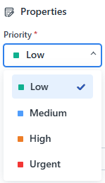

4.6 Review
When an Engineer manually assigns the program to an Agent for Review, the system shall notify designated Reviewers when a request requires their review. Notifications shall be delivered through both workflow (in-app) and email channels.
Pre-condition: Program draft is completed and marked for review; Status changed to “sent for review”
System Behavior:
- The notification shall contain a clickable link that redirects the Reviewer directly to the App and the specific program/request.
- Notifications must clearly identify the request details (e.g., request ID, client, service line) to provide context before review.
- Both in-app workflow notifications and email notifications shall be triggered simultaneously to ensure no review request is missed.
4.7 Approvals
When an Engineer submits a Program for review, the system routes the program for approval based on its matrix color.

The system shall support a structured, color-coded review and approval workflow based on program/job complexity, as well as handle multi-job and multi-program submissions.
Pre-condition: Program review is completed and marked for Approval. Status changed to “sent for Approval”
Approval Rules (by Color):
- Green → Peer Review required.
- Yellow → Manager/Lead Review required.
- Red → Manager Approval required.
- Black → Manager + Director/VP Approval required.
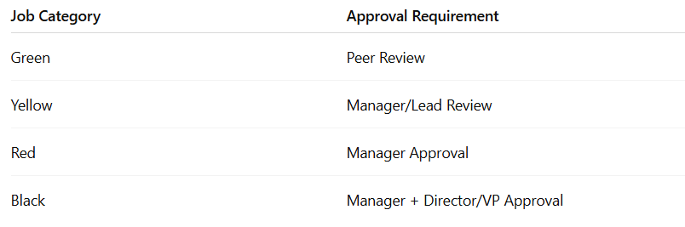

System Behavior:
- The system shall support multi-job approvals, where each job type (e.g., surface, intermediate, liner) follows its own workflow path.
- The system shall support multi-program requests within a single submission.
- The system shall send email notifications to the assigned Approver(s), containing:
  - A link to the App.
  - A link to the associated document for review.
- The system shall log all approval activities, including:
  - Date/time of approval.
  - Decision outcome (approved/rejected).
  - Reviewer comments.
- If a job type is rejected, it shall automatically return to the Engineer for revision.
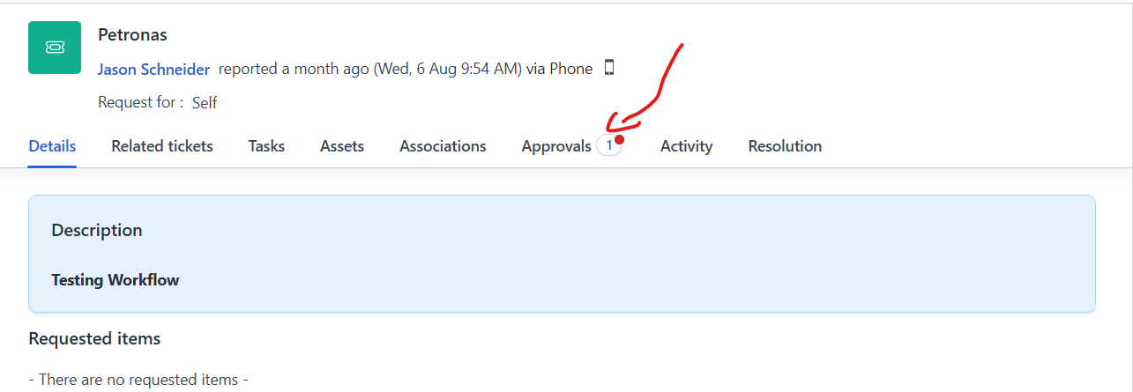
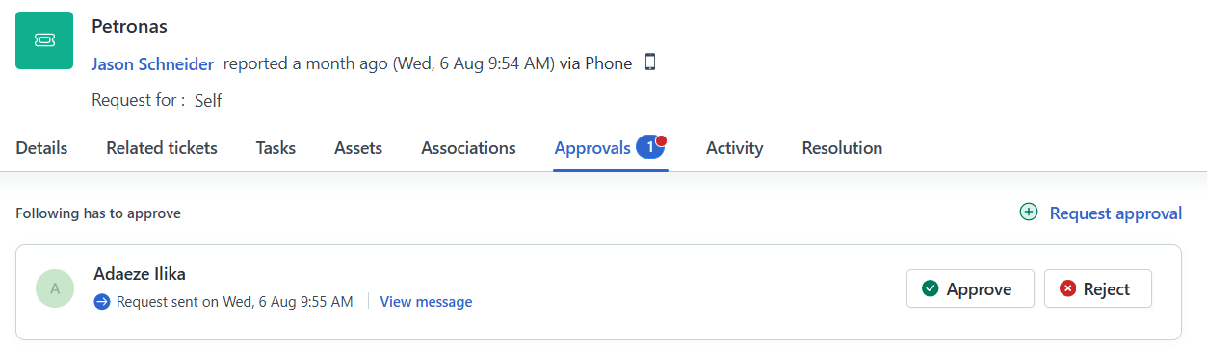
4.8 Multi-Level & Multi-Job Approvals
When a Program Request contains multiple job types, each job type follows its own approval workflow based on its matrix color. The system shall support requests that include multiple job types, each with its own complexity matrix color and associated approval workflow.
Pre-condition: Program Request includes multiple job types (e.g., Surface, Intermediate, Liner).
System Behavior:
1. Each job type within a request may have a different matrix color.
Example: One program could include:
- Green (surface) → Peer Review.
- Yellow (intermediate) → Manager Review.
- Black (Production) → Manager + Director/VP Review.
2.MVP (Minimum Viable Product): The highest authority approver may approve the entire request in a single action.
3.Future Enhancement: The system shall support granular job-by-job approvals, where each job type is reviewed/approved independently.
4.The system shall send email notifications to the assigned Approver(s), containing:
- A link to the App.
- A link to the associated document for review.
5.The system shall log all approval activity, including:
- Approval/rejection date and time.
- Decision outcome.
- Reviewer comments.
6.If a job type is rejected, it shall automatically return to the Engineer for revision.

4.9 Classification
Description: When Sales or Dispatch submits a Program Request, the system must allow the requestor to classify the request as either a Bid, Price Quote, or Awarded Work. This classification will enable accurate reporting and performance tracking across different request types.
Requests categorized as:
- Bid
- Price Quote
- Awarded Work
Pre-condition:
- A Program Request form is submitted with required fields.
- Classification field is available in the intake form.
Post-condition:
- The Program Request is stored with its classification category.
- The system tracks statistics per category (Bid, Price Quote, Awarded Work).
- Users can search, filter, and report requests by classification type.
- Analytics dashboards display conversion rates (e.g., Bids won vs. lost, Quotes issued vs. awarded).

4.10 Document Management
Description: When an Engineer or Sales/Dispatch user submits or updates a Program Request, the system must support document management for review and approval. This ensures all related program files, approvals, and revisions are stored in a centralized, auditable repository.
Pre-condition:
- A Program Request exists in the system.
- The requestor or Engineer has supporting documents (e.g., stick diagrams, licenses, job procedures).
Post-condition:
- Users can attach documents directly into the application.
- Users can optionally link documents from external storage systems (eService, SharePoint).
- All uploaded or linked files are stored with the Program Request.
- The system maintains revision history for updated documents.
- Approvers can access documents directly during the review/approval process.
- Final approved documents are retained for operational use and audit compliance.
4.11 Status (Time Tracking)
Description: When a Program Request moves through its lifecycle, the system must capture and record timestamps for each stage transition. This enables Engineers, Managers, and Sales to track progress in real time and provides a complete audit trail for reporting, SLA monitoring, and accountability. The Status tab will be used for the tracking.
Current Fresh service Stages in the Status Bar:
- Open
- In Progress
- Pending
- Closed
- On Hold
- Resolved
- Awaiting Approval
Required Engineering Team Stages:
- Open
- Received
- Pending
- In Progress
- Completed
- Awaiting Review
- Reviewed
- Awaiting Approval
- Approved
- Sent to Sales / Awaiting Pricing
- Unacknowledged
- Acknowledged
- Sent for Review
- Sent for Approval
System Behavior:
- The system shall capture a timestamp each time a program transitions from one stage to another.
- The system shall maintain a complete timeline of all stage changes to support reporting, auditing, and SLA tracking.
- Each stage transition shall be visible to authorized users, ensuring transparency in program status.
- The system allows exporting or reporting on timestamp data for analysis (e.g., time spent at each stage).
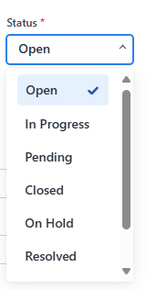
4.12 Quantifying Requests
Description: When an Engineer reviews a new Program Request, the system must provide a field to capture an estimate of effort required to complete the program. At MVP, this is entered manually by the Engineer; in future releases, the system will automatically calculate effort based on program attributes (e.g., job type, matrix color, service line, number of wells).
Pre-condition:
- A Program Request has been logged and assigned to an Engineer.
- Program attributes (job types, service line, matrix score) are available in the system.
Post-condition:
- Engineers can manually input a level of effort estimate (e.g., hours, complexity score).
- The value is stored with the Program Request and can be reported.
- In future versions, the system automatically calculates an effort score and compares it with manual input for accuracy.
- Reports and dashboards reflect estimated effort by Engineer, company, and service line.
4.13 Service Line Differentiation
Description: When a Program Request is created, the system must auto flag (Preferrable) or allow the requestor (Sales or Dispatch) to flag the request with its applicable service line: Primary, Remedial, Stimulation, or Infrastructure. This classification determines the approval workflow that will be applied.
Service Line categorized as:
- Primary
- Remedial,
- Stimulation, or Infrastructure
Pre-condition:
- A Program Request has been submitted with basic required fields.
- Service line selection is available in the request form.
Post-condition:
- The Program Request is tagged with its service line (Primary, Remedial, Stimulation, or Infrastructure).
- The system applies the correct approval structure according to the selected service line.
- Approvers and Engineers can filter or search requests by service line.
- Reporting dashboards reflect request volumes and approval cycle times by service line.

4.14 Step-by-Step Visualization
Description: When a Program Request is created, the system provides a visual tracker that allows users (Sales, Engineers, Managers, Approvers) to see where the program is in Sanjel’s process. Users trigger this by opening a program record in the application.
Pre-condition:
- A Program Request exists in the system.
- Program ID and basic request information are logged.
Post-condition:
- A real-time status tracker is displayed with the following lifecycle stages:
  - Request Received
  - Assignment to Engineer
  - Draft in Progress
  - Under Review/Approval
  - Approved / Rejected
  - Ready for Pricing
  - Executed / Lost Bid / Invoiced
- Users can toggle between high-level view (overall status) and detailed steps (approvals, comments, timestamps).
- The tracker automatically updates as the request progresses through each stage.
- Users can visually identify bottlenecks or pending approvals.

4.15 Search Functionality
Description: When a user searches for a Program Request, the system filters results based on entered criteria. The system shall include a search function to filter and locate program requests quickly.
Users should be able to search using multiple criteria, including:
  - Depth range
  - Temperature range
  - Products used
  - Geographic area
  - Client name
  - Program ID
  - Job type or matrix color
- Search results should return in less than ? seconds.
- Results must be displayed with sortable columns (e.g., date, status, client).

5. Non-Functional Requirements
- Integration: FreshService APIs or custom app.
- Usability: auto-populate fields, simple interface.
- Performance: ticket creation < 2s, search < 3s.
- Auditability: log all actions, assignments, approvals, comments.
- Security: role-based access control.

6. Reporting & Analytics
- Turnaround Time (avg, by company/Engineer).
- Program distribution by matrix color.
- Lost bids vs. won %.
- Workload by Engineer.
- Approval cycle duration.
- Requests by type: Bid, Quote, Awarded Work.

7. Future Enhancements
- Automated prioritization engine.
- AI-driven Engineer assignment.
- Configurable workflows per service line.
- Granular per-job approvals for multi-job programs.

